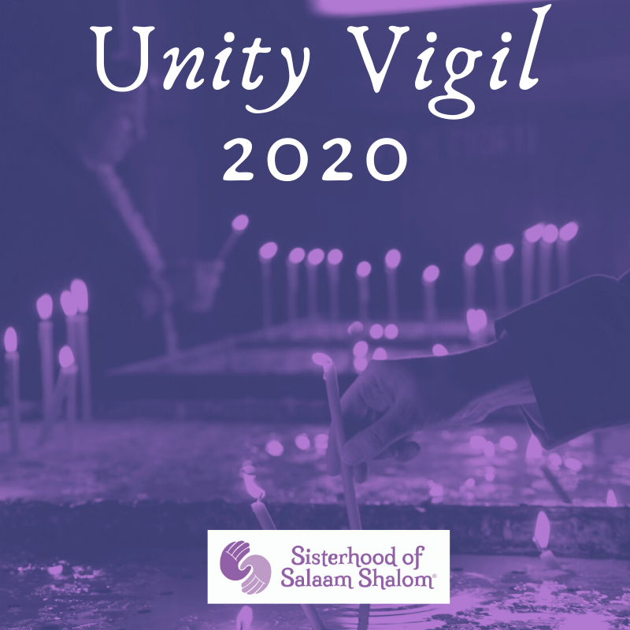

Date:

Time:

Location:

Gather with us to affirm each other and to remind each of us that we are not alone. We will give each other the strength and courage we need to gain control.

Join us as we reflect on our traditions and teachings and create a welcoming space for all. The Sisterhood of Salaam Shalom Unity Vigil is an opportunity to affirm the harmony that we experience when we celebrate the dignity and diversity we see in one another. This vigil will be a call for prayer and readings to offer courage and hope to one another.

For questions contact: