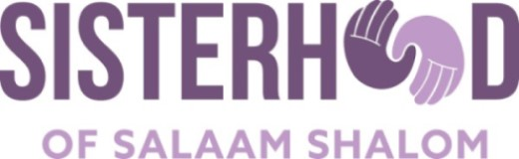

Appendix Five

Letter for Invitation to Press Conference

If your Sisterhood chapter wants to make a statement at press conference scheduled by another organization, here is a sample letter to guide your request:

Director of Interfaith Relations
Interfaith Ministries of Greater Houston

Date: March 29, 2019

Subj: Press Conference participation by the Sisterhood of Salaam Shalom
Dear ________________,

It has come to our attention that you are organizing a press conference in response to the recent arson attack on Northshore Islamic Center, on Friday, April 5, 2019, at 2:30 pm at the mosque. We further understand that you are reaching out to communities of faith and interfaith partners to join this effort.

I am contacting you on behalf of my local chapter of the Sisterhood of Salaam Shalom, a grassroots organization in the US and Canada dedicated to fighting hate against Muslims and Jews (https://sosspeace.org). As Muslim and Jewish women standing together, the Sisterhood of Salaam Shalom, Houston Chapter, will make a powerful statement against this incident of hate. Please let me know if the Interfaith Council can accommodate a brief statement from the Sisterhood of Salaam Shalom in your upcoming press conference. Feel free to contact me at: (insert email address and phone number) if you have any questions or concerns. I look forward to hearing from you.

Your Name
Sisterhood of Salaam Shalom
Your Chapter Name #RiseandResist

