Appendix Seven

Writing an Op-Ed (Opinion Editorial)

An Op-Ed is written by someone who is considered an expert on a subject and their opinion carries weight due to their expertise. But as you can see by the example, we are all experts in the field of interfaith relations!

Here is a list of best practices in writing an Op-Ed:
- Research the paper’s previous coverage on the subject and understand how your op-ed will advance the discussion. Be sure to stay within their word limit.
- State why your unique perspective is important and relevant today.
- Use an active voice to express your opinion.
- Be succinct and sharp in expression, without relying upon jargon.

Sample Op-Ed
Written by none other than West Hartford Sisterhood Teen, Olivia Rotter

This International Women's Day, Look to the Sisterhood of
Salaam Shalom for Inspiration
"We are teaching the world how to 'love thy neighbor.'"
By Olivia Rotter
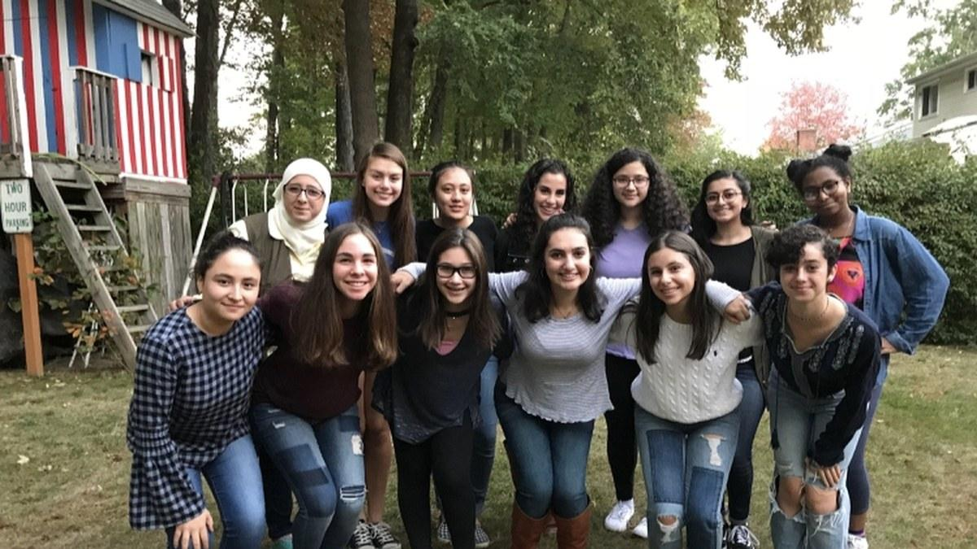
March 8, 2018 Courtesy of Olivia Rotter

In this op-ed, Olivia Rotter, a junior at Hall High School in West Hartford, Connecticut, explains the importance of the Sisterhood of Salaam Shalom.
Who would have thought that nearly 600 Jewish and Muslim women would gather in celebration of each other? Until joining the Sisterhood of Salaam Shalom, I’d have considered that vision a pipe dream, part of an imagined America that wasn’t plagued with the religious, racial, and ideological divides that seem to be emerging around us. But that hopeful vision is, in fact, a reality — and I saw it firsthand at the annual national conference of the Sisterhood of Salaam Shalom in November 2017.
The Sisterhood of Salaam Shalom is an organization that is defying all odds. By providing a space for Muslim and Jewish women — women who belong to religious groups that have historically been at odds — to build relationships and share their stories, the Sisterhood works toward the larger goal of ending anti-Muslim and anti-Jewish bigotry. It's work that is sorely needed in today’s America. believe the Sisterhood of Salaam Shalom is essential to the success of our country, not only for the specific work it does but because it demonstrates a model of building bridges across difference — in this case, across religious faiths — that is truly successful in reducing bigotry.

https://www.nytimes.com/2017/08/25/opinion/tips-for-aspiring-op-ed-writers.html
https://www.teenvogue.com/story/this-international-womens-day-look-to-the-sisterhood-of-salaam-shalom-for-inspiration

