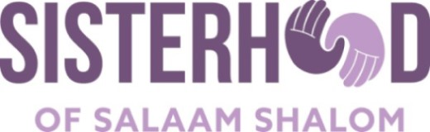

Dialogue Vs. Debate

Dialogue | Debate
Goal: To seek mutual understanding through use of carefully crafted questions. | Goal: To win. Attempt to prove the other side wrong.
Helps people to re-examine positions and assumptions. | Requires that people defend their positions and assumptions.
Use listening to gain insight into beliefs and concerns of others. | Use listening to find flaws and make counter arguments.
Pre-meeting communication essential to process. | Pre-meeting communication is minimal.
Participants speak as individuals with unique experiences | Participants speak as representatives of groups.
Assume that many people have pieces to the answer. | Assume that there is a right answer.
Participants express uncertainty as well as deeply held beliefs. | Participants express total commitment to their point of view.

Adapted from Fostering Dialogue Across Divides, Public Conversations Project, Maggie Herzig and Laura Chasin, p. 139.

