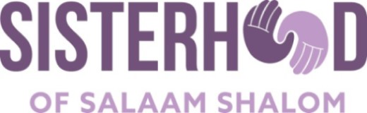

Our Commitments to Each Other

OBJECTIVE: To articulate shared intentions for participating in the Sisterhood of Salaam Shalom.

INTRODUCTION:

As Muslim and Jewish women, we share many values and beliefs in common. However, there are also very real differences, both between our communities, as well as within our own community. Rising Islamophobia and anti-Semitism can deepen mistrust and sow fear about the other.

To strengthen our relationships and to address our differences, participants in the Sisterhood of Salaam Shalom agree to:

- Pursue sustainable friendships that are based upon mutual respect.

- Listen to each other while respecting our differences.

- Speak out in public, guided by faith, reflection, and experiences, to preserve and protect religious freedom.

- Speak out against all forms of prejudice, hatred, and discrimination.

- Accept that everyone in our Sisterhood has equal status and equal voice.

- Commit to and participate in regular meetings.

- Commit to learn more about our own faith and practices, as well as the practices of Sisters from the other faith.

- Embrace change in our own assumptions, perceptions, and practices as our knowledge level increases.

- Refrain from hateful and hurtful language, facial expression, or body posture.

- Pay attention to etiquette and respect differences in daily living.

- Not seek to convert the other.

- Avoid dialogue about the Israeli-Palestinian conflict until trust and respect has been established among chapter members.

