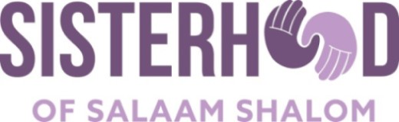

Tips for Crafting Great Questions

Goal: To create questions that elicit new understanding, especially when you don’t agree.

Introduction: There are so many questions that might spark meaningful conversation, it can be difficult to know where to begin. So, consider beginning at the end! Your dialogue or meeting just ended and it was spectacular. You exceeded your goal and hopes. What happened? Did any questions elicit, “oh, I hadn’t thought of that before; that’s really interesting?” Did any questions help you gain a new understanding of someone’s experiences or values? Those are the questions that you’re looking for!

To simplify your process, it can be helpful to explore three categories of questions, in this order:

- Personal life experiences
- Values, hopes, and fears
- Doubt and uncertainty

Below are some examples of questions in these three categories. Fill in the blank; they can be used for virtually any topic:

- A person’s life experience
  - “What is the meaning of (fill in the blank) in your life?”
  - “What/who has shaped your perspective or belief?”
  - “Can you tell me more about what (fill in the blank) means to you?”

- The “heart of the matter”
  - “When you think of (fill in the blank) what is most important to you?
  - “Have your values and beliefs about (fill in the blank) changed over time?
  - “What are your hopes and fears, both now and for the future?”

- Any areas of doubt or uncertainty.
  - “Is there an important value that you hold around (fill in the blank) that may conflict with another value that is also important to you?”
  - “Can you think of a time when you felt discomfort as you explored a deeply held belief about (fill in the blank)?”
  - “As you think about (fill in the blank), do you have any dilemmas or gray areas that you’d be willing to share?”

Great Questions are:
- Open-ended. They are difficult to answer with a “yes” or a “no”. Instead, they encourage deeper thinking, sharing of emotions, and reflection upon underlying values and beliefs. Responses often give the listener new information.

- Not embedded with solutions. There is no implied “right” answer to the question. Great questions avoid a subtle or inferred solution. Your goal is to more deeply understand the speaker’s experience, not impose your point of view.

- Specific. They ask the speaker for details and data to help you more fully understand her experience.

- Personal. They ask the speaker to share her personal, family, or community experience and relationship to the topic or issue.

The categories and sample questions are based upon the manual, Fostering Dialogue Across Divides: A Nuts and Bolts Guide from the Public Conversations Project (now called Essential Partners). It is available for free download on their website: www.whatisessential.org.

